Clinton Hawkes
CS261-400
Assignment 0
Introduction:
My name is Clinton, but I go by Clint. I was born and raised int Blackfoot, Idaho. It’s a tiny town of 10,000 people, and everybody seems to know everybody. I don’t really like the fact that everybody knows your business, but it is a nice town to live in. This area is close to the mountains, so I enjoy fishing, camping, and going on hikes with my daughter. I also like to cook a variety of food in my spare time. Whether its grilling the perfect steak or making Thai green curry, I love it.
I received my first bachelors degree from Idaho State University. I had a difficult time deciding whether I wanted to pursue economics or computer science, and in the end, I chose economics. One of the economics professors swayed me in that direction. He taught the concepts in a manner that developed real enjoyment for me. After graduating from ISU with a bachelors in economics, I felt the need to move from my quiet town. In the past 10 years I have lived in ID, NC, TX, OK, and NM. My favorite thus far has been Texas, and I plan to move back after I graduate from this program at OSU. There seems to be a lot of opportunity for computer science majors in Texas, so I hope to get an internship or position there.
I honestly don’t know what I want to do after this program. I know that I enjoy programming, but there are a lot of areas in computer science that interest me. I came into this program thinking that I did not want to become a web developer. Now I am not so sure. I don’t think I fully understand what web development entails. I plan to gain a better understanding of the different options available before I make any decisions.
I have loved this CS program at OSU thus far. There are a lot of things done right (in my opinion), and a lot of things that need improved. I know there is a large variance in the amount of coding experience each students possesses, and I tend to let most of my gripes slide because of this. You can’t make everybody happy, and I think OSU is providing a good education overall.
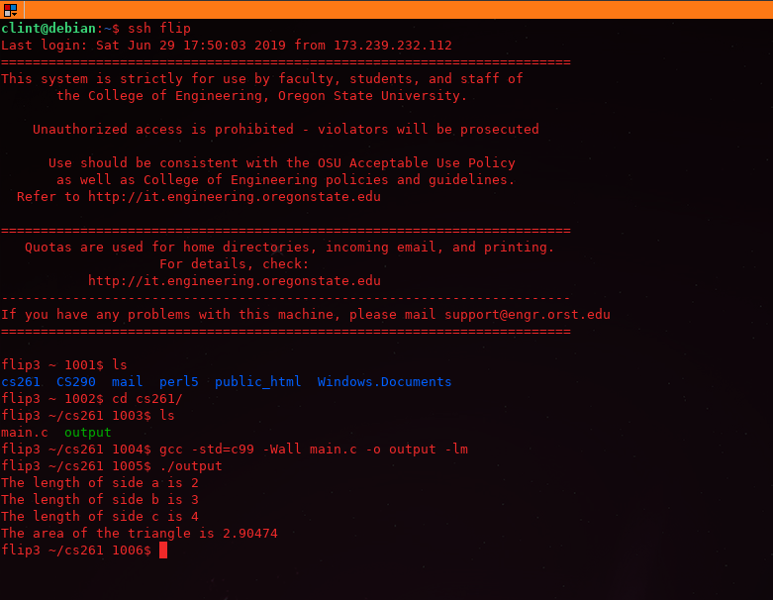
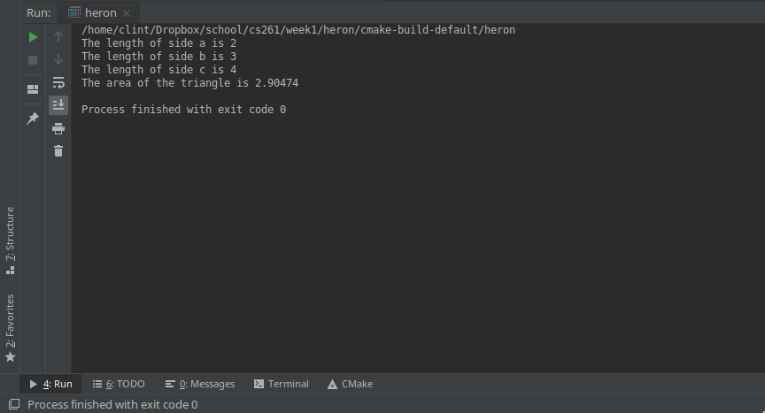
Flip Screen Shot

IDE Screen Shot

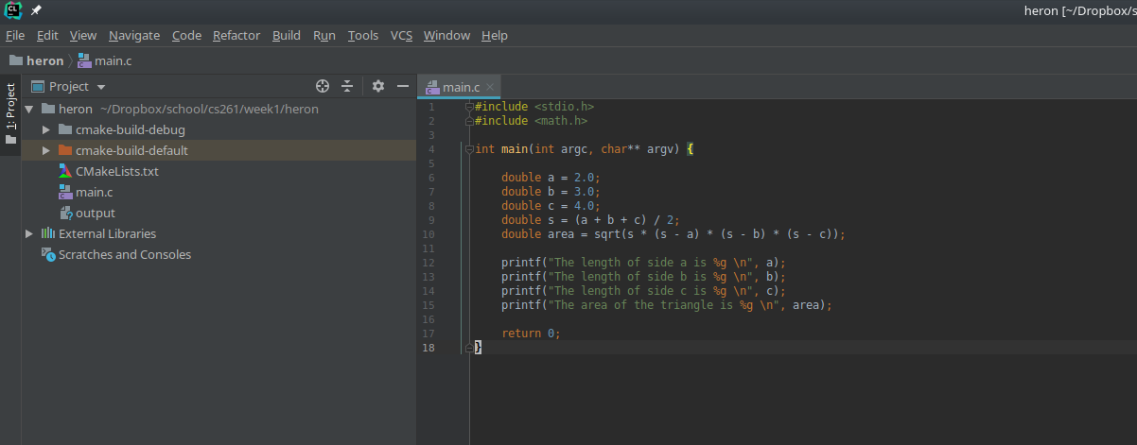
Source Code Screen Shot

